Intro



Friday, February 13, 2015

3:54 PM

**Understanding hadoop**

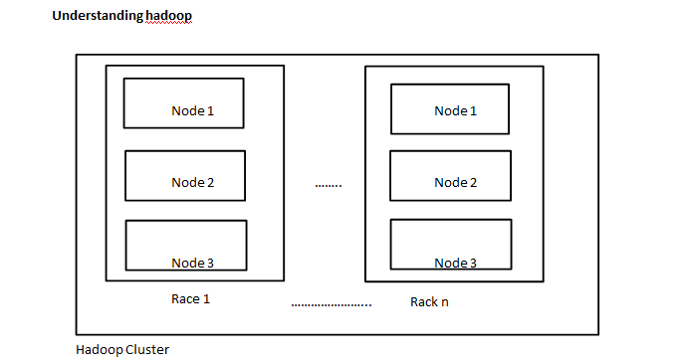

Hadoop Cluster

* + Hadoop has two components
  + Distributed file system -> Storage
  + MapReduce Engine -> Processing

**HDFS**

-> uses sequential data access rather than random access

-> hadoop reduces seeks by using larger files, bigger the file lesser the seeks required to check for file in the file system

-> hadoop uses blocks to store files or parts of files

-> HDFS blocks are supported by multiple OS

-> Advantages of blocks:

->>fixed size and hence easy to calculate how many fit on the disk

->> file can be larger than single disk, will be put in multiple blocks

->> if the file size is small, it will not acquire all the data of the block, the blocks will be formed accordingly

If 400 MB of data

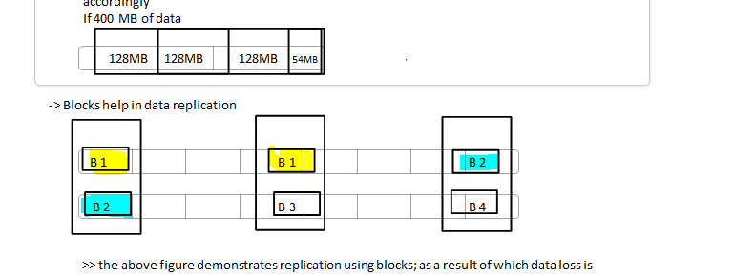

->> the above figure demonstrates replication using blocks; as a result of which data loss is prevented

->> even if one node goes down, the other nodes have the replicas of the blocks

**HDFS nodes vs MapReduce nodes**

|  |  |
| --- | --- |
| HDFS nodes | MapReduce nodes |
| -NameNode | -JobTracker |
| -DataNode | -TaskTracker |

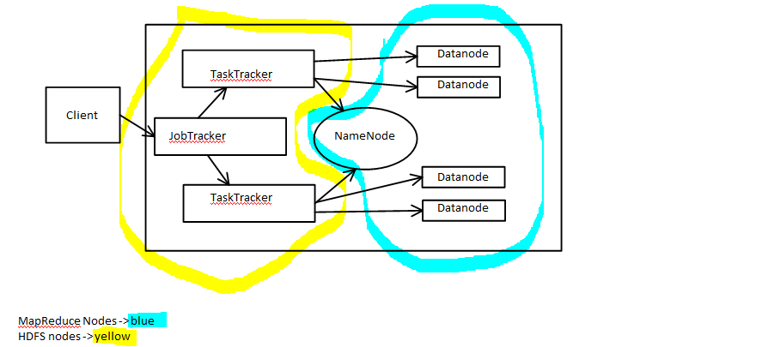

MapReduce Nodes -> blue

HDFS nodes -> yellow

-> Client can communicate with JobTracker or NameNode or DataNode

**Namenode**

->only **one** per hadoop cluster

-> Manages file system namespace and metadata

-> states should be written to multiple FS

-> large memory/RAM requirements

**Datanode**

-> many datanodes per hadoop cluster

**->** Stores blocks of data

-->> when client requests for data, the DN finds out from its NN, which data block resides where, and which data blocks together make up for the requested file

-> client directly reads data from DN's

-->> Each DN reports to its NN about the blocks it stores

-->> The blocks of a file are replicated for fault tolerance

**JobTracker node**

-> only one per hadoop cluster

-> manages MapReduce jobs

-> receives job requests sent by client

-->> schedules/monitors MapReduce jobs on TaskTrackers

**TaskTrackers**

-> required for parallel processing using multiple mappers

-> executes MapReduce operations

-> many per hadoop cluster

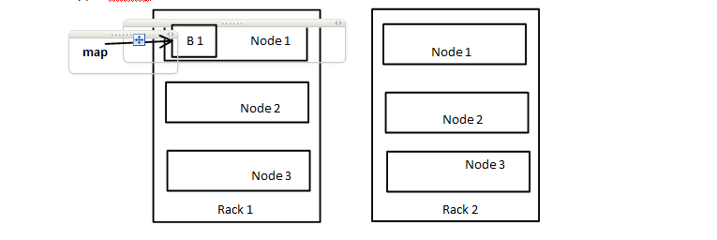

-> To run job on B1 in rack 1, its better to use the task tracker on the same node where B1 resides

-> if not, we can use another node of same rack

-> worst case hadoop supports is using the node of another rack of same cluster